Tourism Management System

I.Introduction

Now a day’s number of people, using internet is increasing exponentially, so the use of web applications is also increasing. This is a proposal to design a web application for booking a package for Tourists.

Tourism Management System is a web application which gives information on packages available to the users, the user has to register/login the web application and select the package and book the package for a particular date. The user can change the package or cancel the package at any time. User can also change the date of the package. The user can select the food they want to eat from the menu and they can modify the items or can delete the items.

The functionalities used in this application are

|  |  |
| --- | --- |
| **Admin** | **User** |
| Add Package | Book Package |
| Add Room | Book Room |
| Add Food | Book Food |
| Add Transport | Book Transport |
| Update / Delete Package | Modify / Cancel Package |
| Update / Delete Room | Modify / Cancel Room |
| Update / Delete Food | Modify / Cancel Food |
| Update / Delete Transport | Modify / Cancel Transport |
| Add Discount | Confirmation Details |
| Update /Delete Discount | Payment |

II. Agenda

This site helps the user to book any kind of package they want. The packages are the displayed in a table according to the packages name selected by the user. The total usage scenario is explained below by category wise. The site has two kind’s usages user and admin

## User:

1. User should register to the site with all the required details. And then he/she can login to the site. User can also reset their password if they registered already.
2. User can search for the packages which were added by the admin. He/ she can view the packages with place in a table by selecting any package name displayed in the dropdown box.
3. User can book their food, transport and room only if they book any package in the site. If they don’t book any package then they cannot book any of the things listed above.
4. User can view different types of room and size of room by selecting the hotel name. Coming to food they can book any kind of food by selecting type of food they want. Similarly they can book there transport by selecting the mean of transport they want to travel.
5. User can view there packages, food, room and transport they have booked and they can modify / cancel them according.
6. Finally they can view their conformation page where they can see the total cost of the package that is sum of package cost, room cost, food cost and transport cost so that they can pay the total money.
7. In this payment they will get 10% discount for their first package and 30% discount for their 3rd package. In additional to the 10% for the 1st package they can get any additional discounts if available for the selected package which are added by admin.

## Admin:

1. Admin can add packages he/she want. While adding the package he should give the package name, place, number of days, cost. If he/she add same package name with same place the package will not be added if admin add same package name but different place then it will be added.
2. Admin should add hotels first so that he/she can add rooms later with respective to the hotel name. In room admin should add type and size of the room and finally cost of the room.
3. Admin can also add the food by selecting which type of food he want to be added.
4. Finally he/ she can also add the transport like which type of vehicle user may need.
5. Admin can update/delete the package, room, food and transport which was added by him/her.
6. He/she can add the percentage of discount for any package which was selected by user as his/her 1st package.
7. Admin can also update the discount program like changing the discount percentage or deleting the discount.
8. He/she can view all the payment details finally made by the users.

III. Developed by : Achal Ashok Sakure

Something about me : My name is Achal Ashok Sakure. I am a B.E. graduate in Computer Engineering from Manoharbhai Patel Institute Of Engineering And Technology, Shahapur, Bhandara passout in 2018. I am currently learning Core Java, SQL, JDBC Connectivity, Jsp ,Servlets ,Spring , Hibernate ,HTML and CSS.

IV. Procedure

## Hardware and Software used

Processer : Intel i3

RAM : 4 GB

Operating System: Windows

## Technology used

Database : MYSQL

IDE Tool : Eclipse IDE

Technologies: Servlets, JSP, JavaScript, JQuery, Bootstrap, HTML5, CSS

When user login then user.jsp file will be appeared and then by clicking on the select package it will redirect to package.jsp which is located in user package. After selecting the package name then the bookpackage controller gets all the package from DB and get the package’s which are with package name selected by user and throws them back to the table with all details into the same page with the help of jQuery.

V. Flowchart showing the workflow of this project

## High Cut use case diagram for site

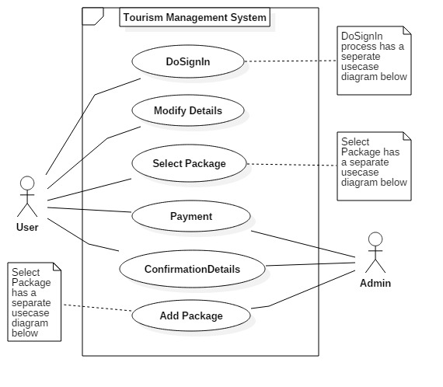

## DoSignIn Use Case diagram

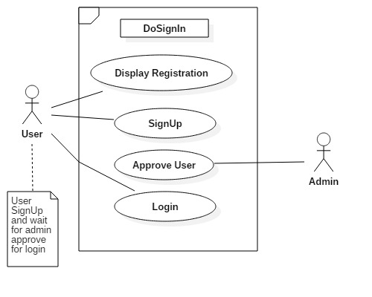

## Select Package use case diagram

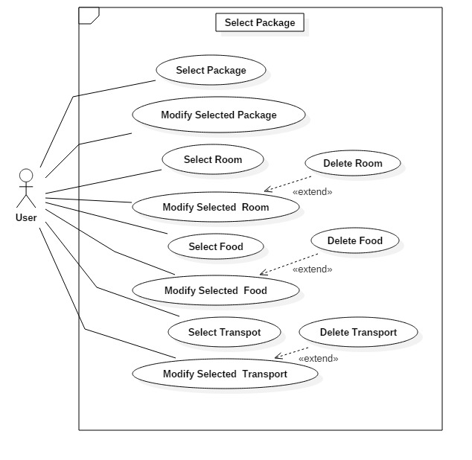

## Add Package Use Case Diagram

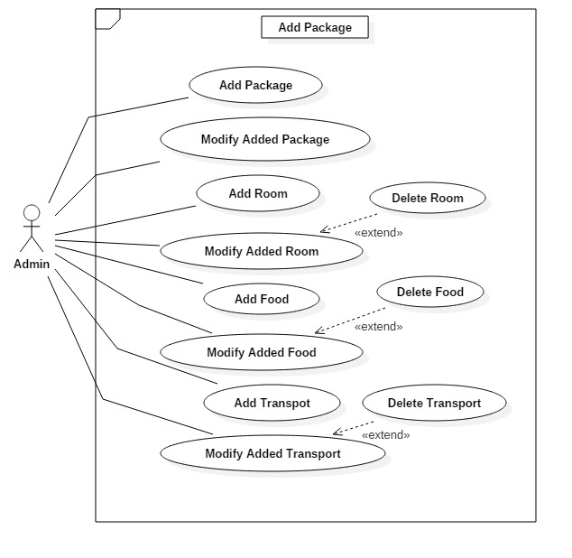

# ER Diagram

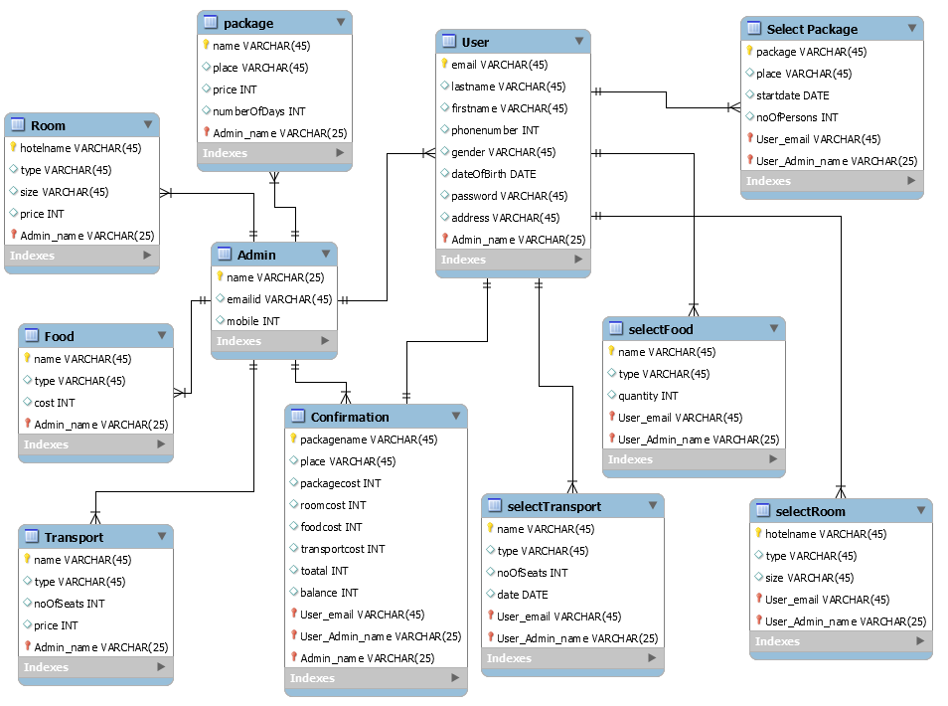

**User**: this stores the data of user information

**Package**: stores the data of all the packages added by admin

**Food**: stores all the data of food added by admin

**Room**: stores the data of all the rooms added by admin

**Transport**: stores all the data of transport added by admin

**Confirmation**: stores all the payment details of all users

**Selectpackage**: stores all data of selected packages by all users

**Selectfood**: stores all data of selected food by all users

**Selectroom**: stores all data of selected room by all users

VI. Conclusion

The main aspect behind “Tourism Management System for students” web application will help the user to save time and money. Many of them spend their time by visiting the office and gather information, discuss with the people and pay the money. By this application user can directly see the packages from his place without visiting any office and wasting their time. Tourism management system is a good application for booking tickets to travel. In old days we don’t have any technology so we should go to the nearest retailer but now a days we no need to go anywhere we can book anything at the same place where we are.